DAY 4 CYBERSECURITY ESSENTIALS ASSIGNMENT TASKS

­Name : N.Raguvaran

Email : raguvaran2804@gmail.com

ASSIGNMENT

Task 1:

Find Mail Servers of the following

1. [www.ibm.com](http://www.ibm.com)

Open command Prompt & type nslookup

Type set type=mx

Enter www.ibm.com

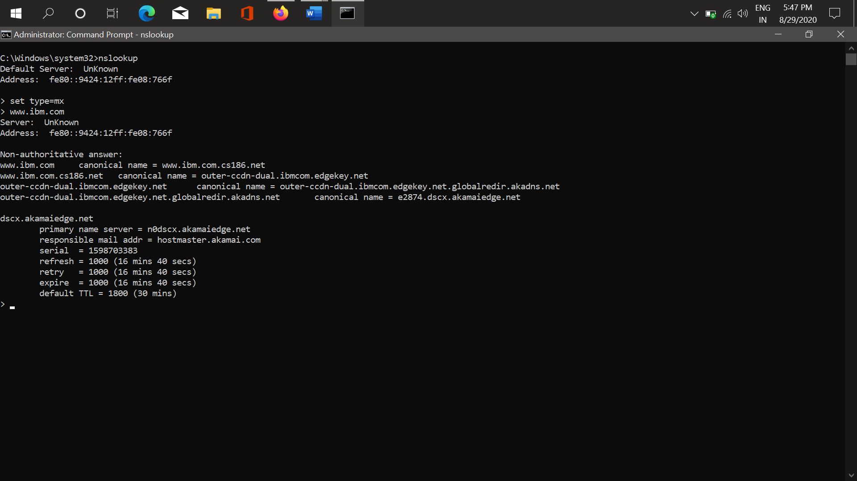

From the results we find the mail server is hostmaster.akamai.com

1. Find mail server of [www.Wipro.com](http://www.Wipro.com)

Open command Prompt & type nslookup

Type set type=mx

Enter [www.Wipro.com](http://www.Wipro.com) & look for mail address

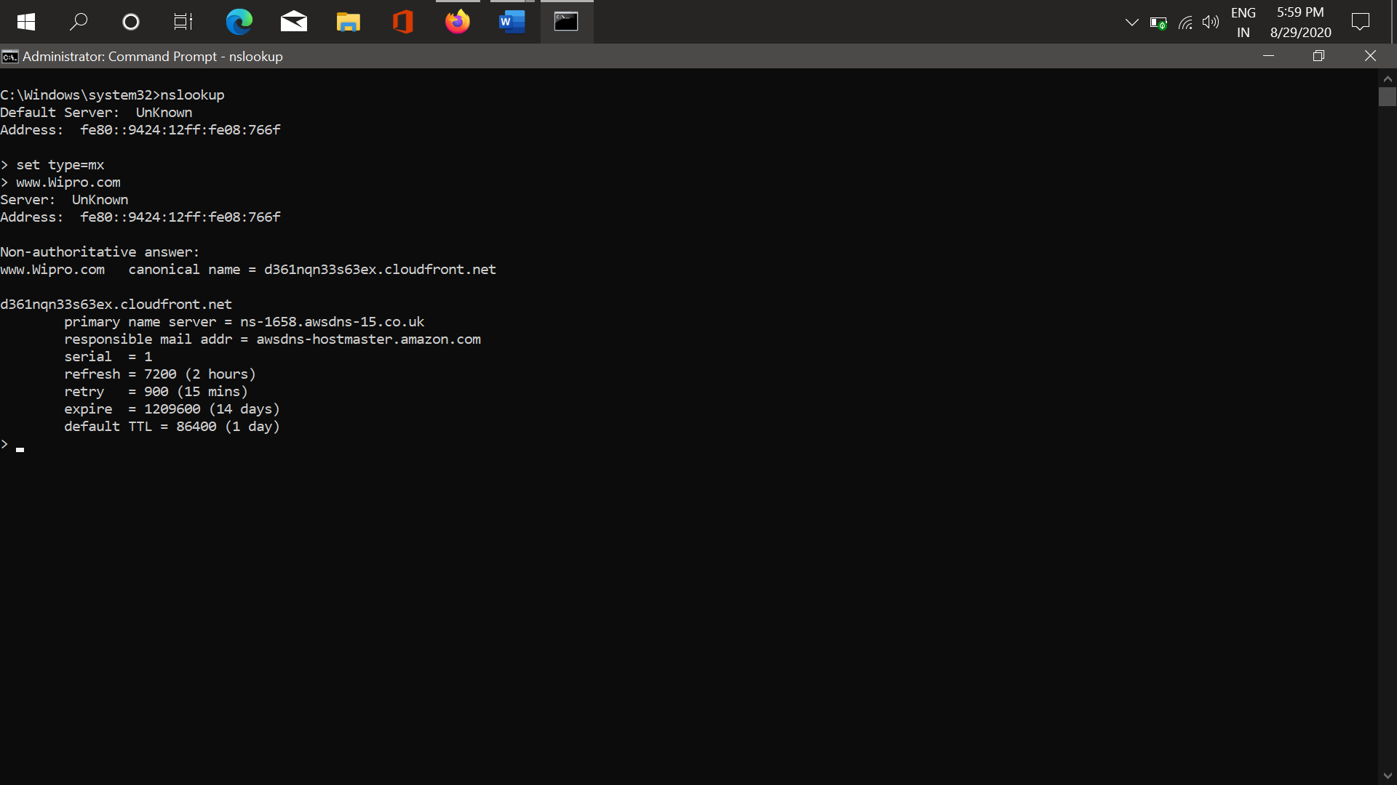

From the results the mail server is

awsdns-hostmaster.amazon.com

Task 2

Find the locations of this Mail Server

A.Ibm.com

Open cmd type commands >nslookup >set type=mx >Ibm.com

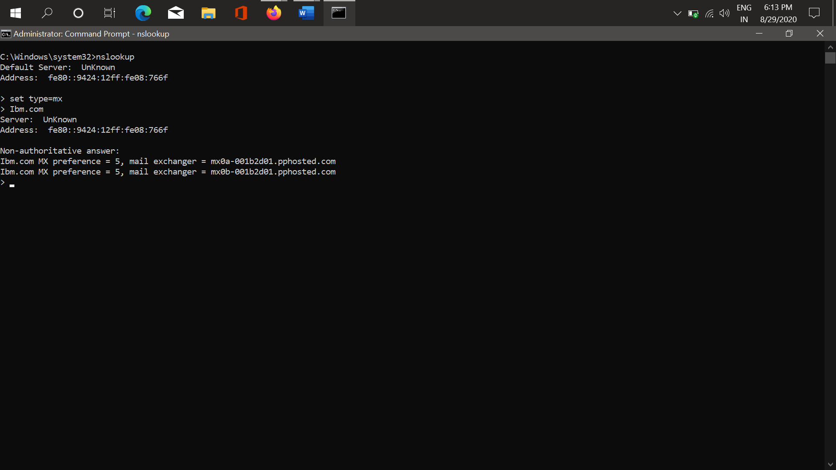

Lets find the Ip Location of the mail server

Address: mx0b-001b2d01.pphosted.com

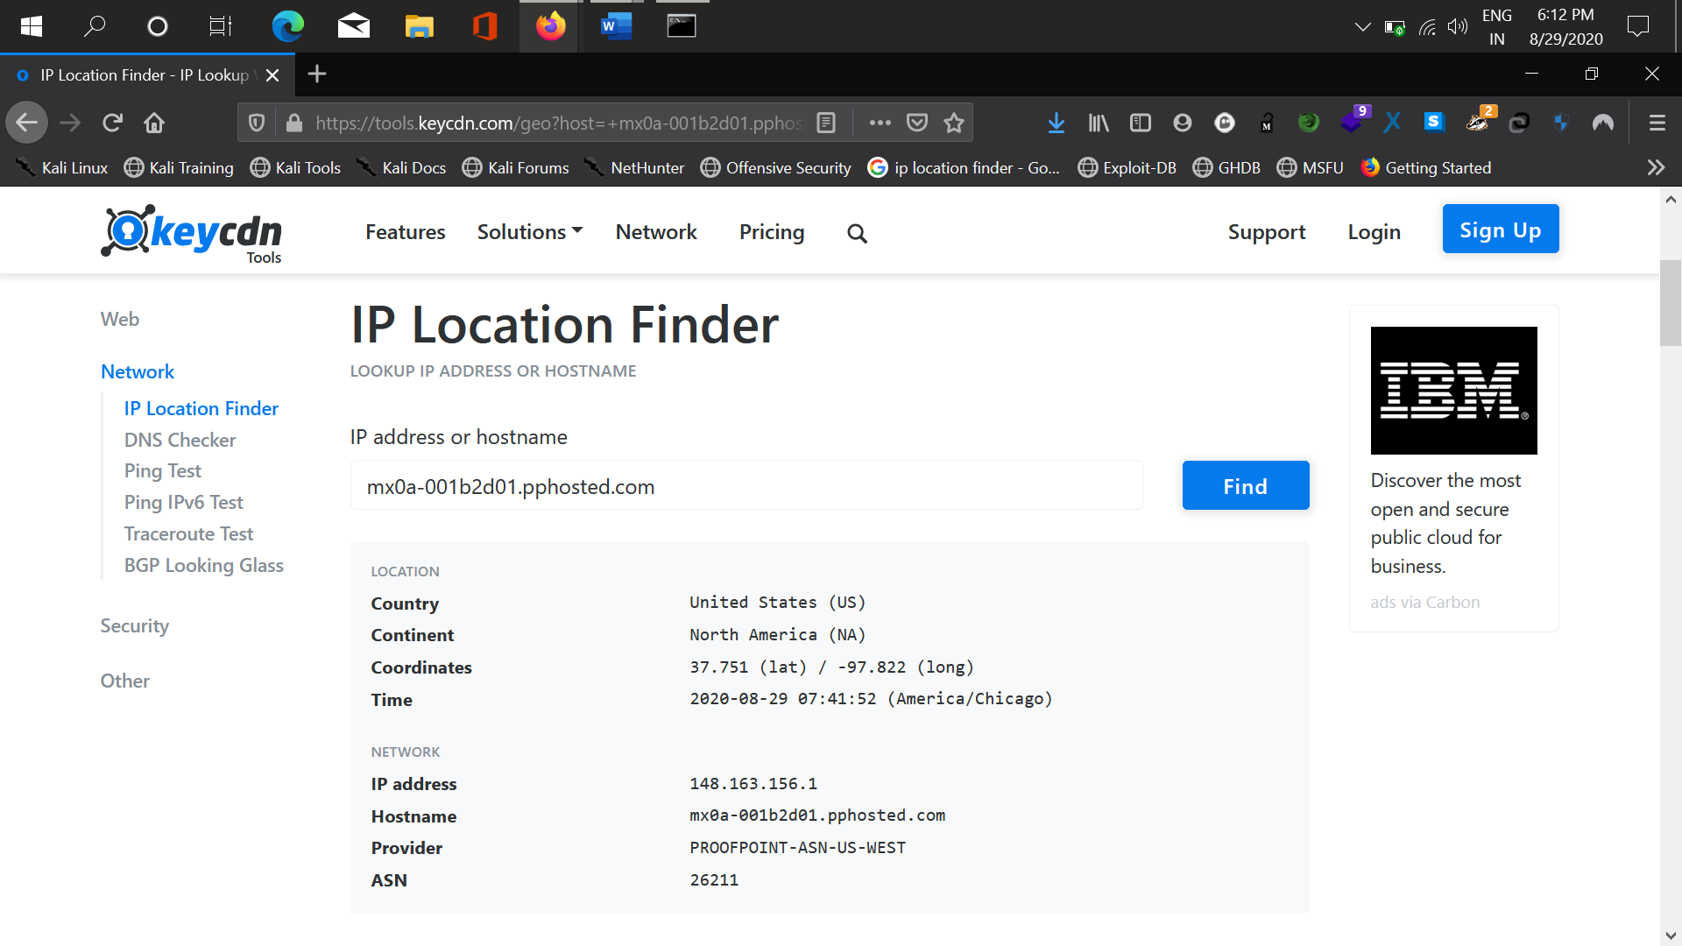

Tool Used is tools.keycdn.com . Location : United States.

Find Location of Wipro mail server location

Open CMD >type and enter nslookup>set type=mx>wipro.com

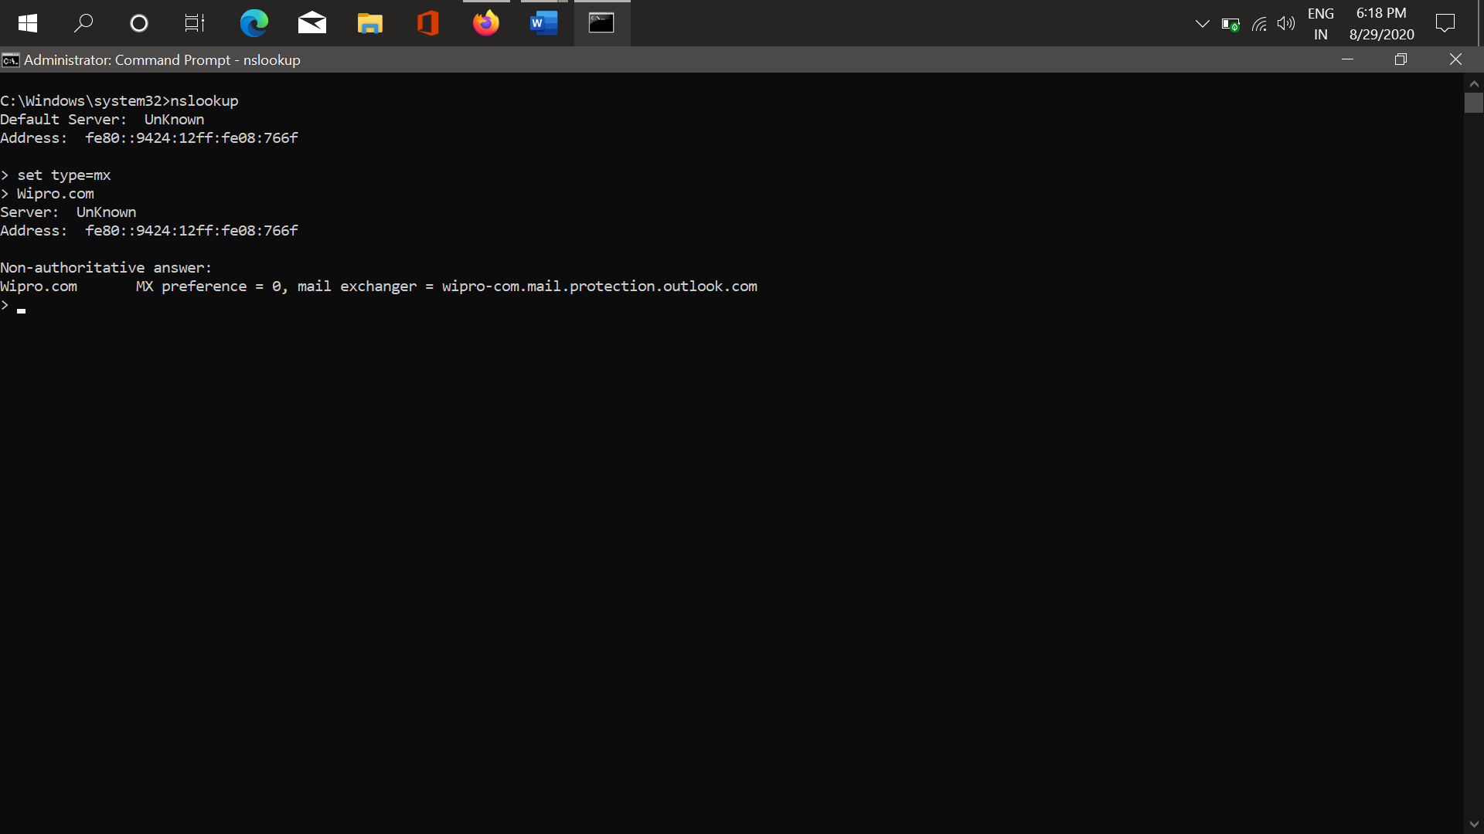

Let’s find the Location of the mail server by using any Ip finder tools.

Address : wipro-com.mail.protection.outlook.com

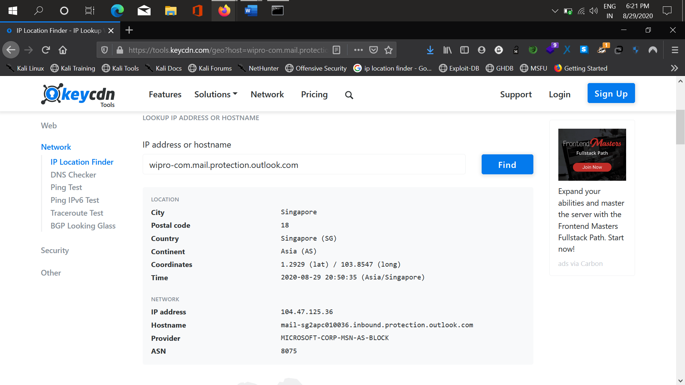

Mail Server Location : Singapore

Task 3. Scan & Find the open Ports in 203.163.246.23

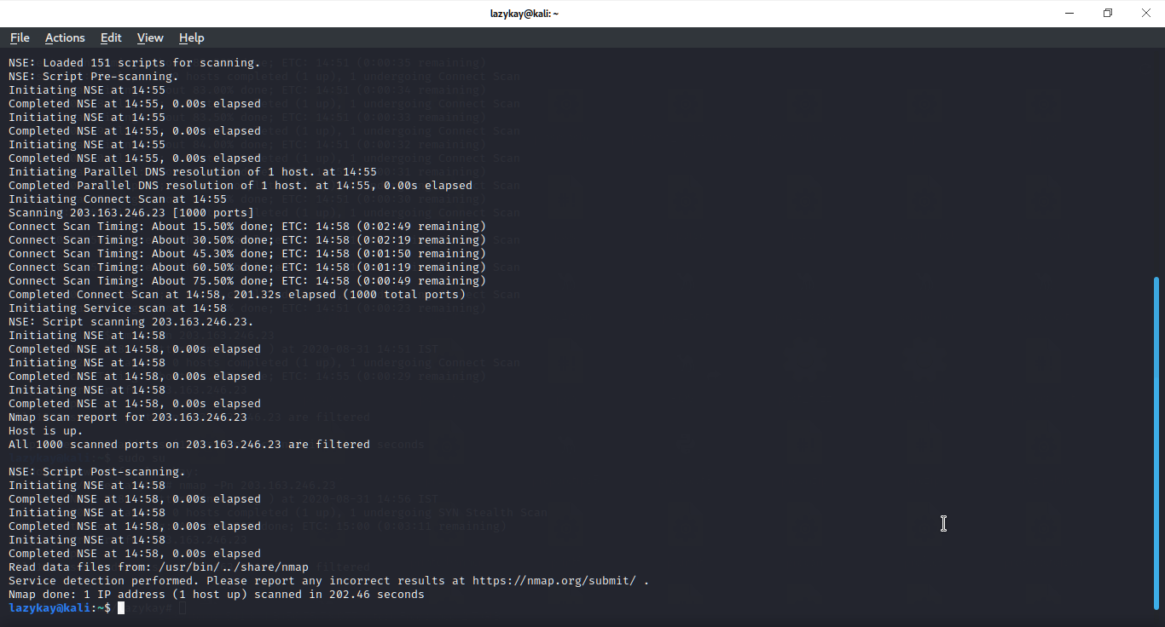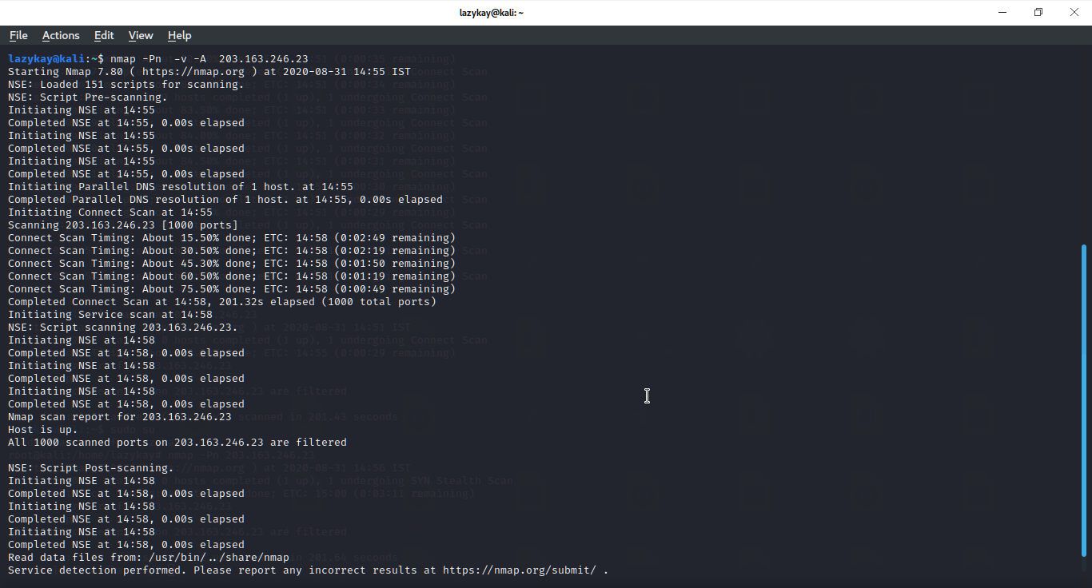

All 1000 ports are filtered. No Open Ports.

Task 4. Install Nessus on VM & Find the Vulnerabilities.

NESSUS installed & scanned the machine.

Choose Scan -> All Scan -> Basic Network Scan to find vulnerabilities in our Desktop / Laptop

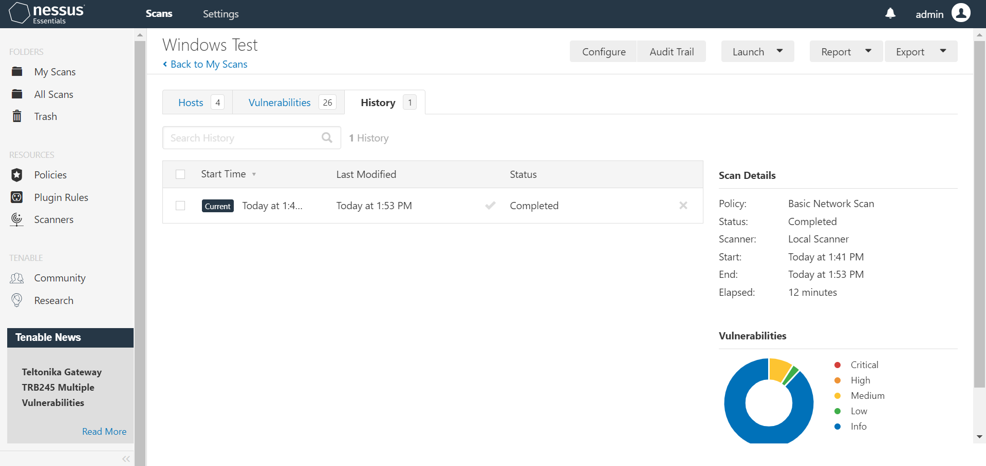

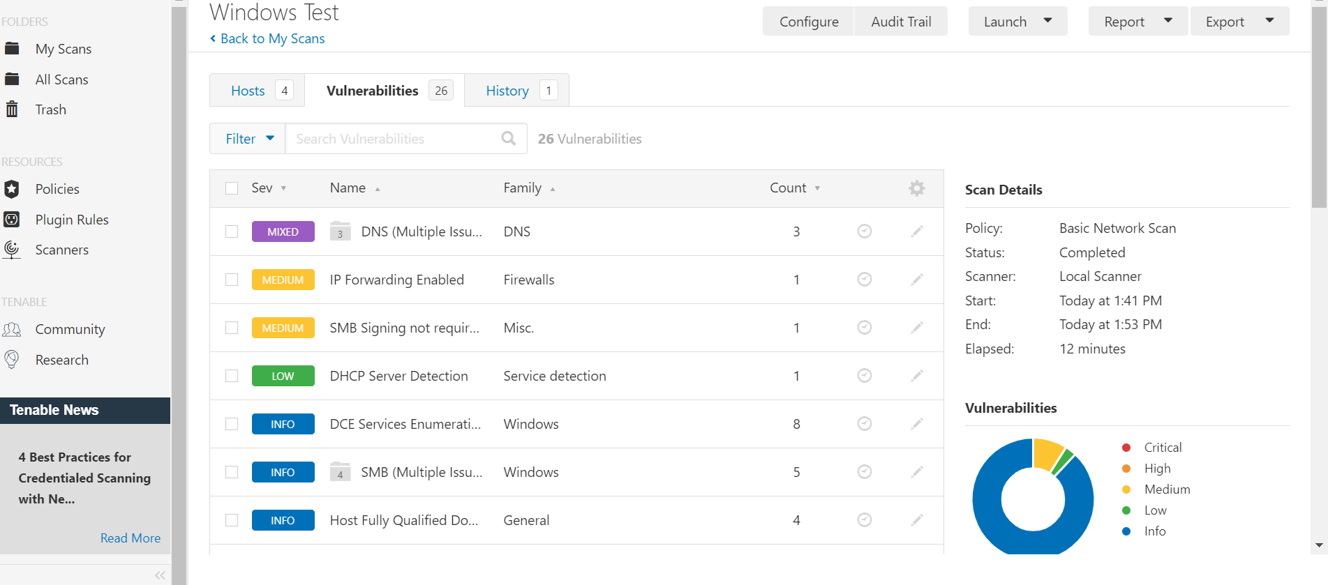

Vulnerabilities are found using NESSUS .